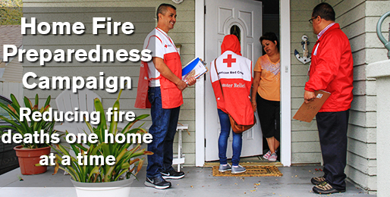

At no cost to you, we would like to demonstrate some simple changes in the home that will help you protect your family against fire. In addition, the Red Cross will install a FREE smoke alarm within your home.
Fill out the form below to request an appointment. Our team will follow up to schedule an appointment for your FREE in-home smoke alarm installation.
During your home visit, you will receive:
- Installed smoke alarms if no working smoke alarms are present in your home
- Guidance in the development of a Family Disaster Plan
- Valuable emergency preparedness tips and information
All demonstration and installation services will be performed by Red Cross-trained volunteers and/or licensed/insured professionals.
http://www.redcross.org/ct/schedule-a-visit

