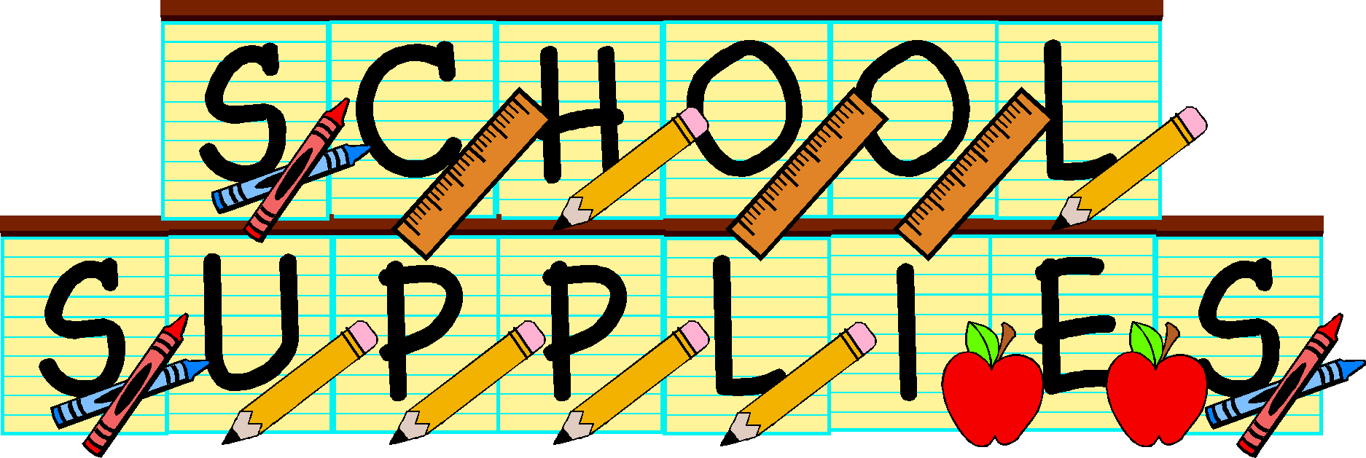

June 19, 2015

Dear Parents,
Below we have listed some basic supplies that Cook Hill students will be using throughout the 2015-2016 school year. In August, your child’s teacher will send a list with a few additional supplies specific to that classroom along with their welcome letter. It would be helpful if you can put your child’s name on each item in permanent marker.
- 4 sharpened # 2 pencils with eraser caps (not decorative pencils)
- Box of crayons (no more than 24)
- 4 glue sticks
- 1 highlighter
- 4 EXPO dry erase markers
- 1 plastic supply box
- 1 marble composition book

Frequently, parents ask if they can donate items for classroom use. The following are items the whole class will use and appreciate:
- Box of tissues – the more the merrier!
- Purell brand only – pump style hand sanitizer
- Ziploc bags (all sizes)

Thank you in advance for your generosity

