Cardiac Emergency Response Plan
WALLINGFORD SCHOOL DISTRICT
This Cardiac Emergency Response Plan is adopted by the Wallingford School District. This plan was reviewed and approved by the district’s medical advisor.
A cardiac emergency requires immediate action. Cardiac emergencies may arise as a result of a Sudden Cardiac Arrest (SCA) or a heart attack, but can have other causes. SCA occurs when the electrical impulses of the heart malfunction resulting in sudden death.
Signs of Sudden Cardiac Arrest can include but not be limited to one or more of the following:
- Not moving, unresponsive or unconscious, or
- Not breathing normally (i.e., may have irregular breathing, gasping or gurgling or may not be breathing at all), or
- Seizure or convulsion-like activity.
Note: Those who collapse shortly after being struck in the chest by a firm projectile/direct hit may have SCA.

The Cardiac Emergency Response Plan of the Wallingford School District shall be as follows:
- Developing a Cardiac Emergency Response Team
- The Cardiac Emergency Response Team shall be comprised of those individuals who have current CPR/AED certification. It will include the school nurse, coaches, and others within the school. It should also include an administrator and office staff who can call 9-1-1 and direct EMS to the location of the SCA.
- Members of the Cardiac Emergency Response Team are identified in the “Cardiac Emergency Response Team” attachment, to be updated yearly and as needed to remain current. One of the members shall be designated as the Cardiac Emergency Response Team Coordinator.
- All members of the Cardiac Emergency Response Team shall receive and maintain nationally recognized training, which includes a certification card with an expiration date of not more than 2 years.
- As many other staff members as reasonably practicable shall receive training.

- Activation of Cardiac Emergency Response Team during an identified cardiac emergency
(a) The members of the Cardiac Emergency Response Team shall be notified immediately when a cardiac emergency is suspected.
(b) The Protocol for responding to a cardiac emergency is described in the “Protocol for Posting” and in detail in the Cardiac Emergency Response Team Protocol, both contained within this document.

- Automated external defibrillators (AEDs) – placement and maintenance

- Minimum recommended number of AEDs for Wallingford School District:
- Inside school building – The number of AEDs shall be sufficient to enable the school staff or another person to retrieve an AED and deliver it to any location within the school building, ideally within 2 minutes of being notified of a possible cardiac emergency.
- Outside the school building on school grounds / athletic fields – After school hours, the AED may be moved from its designated location by an AED-trained athletic trainer or coach to support athletic department activities on an as needed basis. A visible sign must be left in the place of the AED, with the phone number of the athletic trainer and coach, clearly indicating who has possession of the AED. A plan delineating to which practices or activity the athletic trainer(s) and coaches(s) will take the AED to will be established and agreed upon prior to AED implementation. The plan must be the same for all participating Wallingford Public Schools.
- Note: After regular school hours there is no guarantee that there will be someone trained and available to access and utilize the AED.
- The Wallingford School District will regularly check and maintain each school-owned AED in accordance with the AED’s operating manual and maintain a log of the maintenance activity. Each school shall designate a person who will be responsible for verifying equipment readiness and for maintaining maintenance activity.
- Additional Resuscitation Equipment: A resuscitation kit shall be in the AED cabinet. The kit shall contain latex-free gloves, razor, scissors, towel antiseptic wipes and a CPR barrier mask.
- Note: Per the American Heart Association there is insufficient evidence at this time to make a recommendation for the use of AEDs for infants <1 year of age, therefore do not use the AED on children < 1 year of age. Pediatric pads if available should be used on children 1 year to 8 years of age. Per CPR/AED training if pediatric pads are not available you may use adult pads.
- AEDs shall not be locked in an office or stored in a location that is not easily and quickly accessible at all times.
- AEDs shall be readily accessible for use in responding to a cardiac emergency, during both school-day activities and after-school activities, in accordance with this Plan. Each AED shall have one set of defibrillator electrodes connected to the device and one spare set. All AEDs should have clear AED signage so as to be easily identified. Locations of the AEDs are to be listed in the “Cardiac Emergency Response Team” attachment and on the back of the “Protocol for Posting” attachment.
- Important: You must change the 9 volt battery once a year. It is extremely important to do this around the same time every year or sooner if needed.
The larger battery pack is good for 5 years from the date it is put in and the pads are good for two years. You will need to note expiration dates upon installation so you can plan on reordering supplies prior to expiration dates. Supplies will be ordered annually and as needed by the Nurse Coordinator. Any problems with the AED call LIFESAVERS, INC. 1-973-244-9111 and inform the Nurse Coordinator.
- Communication of this Plan throughout the school district

- The Cardiac Emergency Response Protocol shall be posted as follows:
  - Adjacent to each AED.
  - In the gym, near the swimming pool, and in all other indoor locations where athletic activities take place, the auditorium, cafeteria and faculty lounge(s).
- The Cardiac Emergency Response Protocol shall be distributed to:
  - All staff including administrators at the start of each school year.
  - Results and recommendations from Cardiac Emergency Response Drills performed during the school year shall be communicated to the cardiac team and administrative personnel of the particular school.

- Training in Cardiopulmonary Resuscitation (CPR) and AED Use

- Staff Training:
- In addition to the school nurse, a sufficient number of staff shall be trained in cardiopulmonary resuscitation (CPR) and in the use of an AED to enable the Wallingford School District to carry out this Plan. Training shall be renewed at least every two years. The school shall designate the person responsible for coordinating staff training.
- Training shall be provided by an instructor, who is currently certified by a nationally-recognized organization to conform to current American Heart Association guidelines for teaching CPR and/or Emergency Cardiac Care (ECC).
- Training may be traditional classroom, on-line or blended instruction but should include cognitive learning, hands-on practice and testing.
(b) Cardiac Emergency Response Drills:
Cardiac Emergency Response Drills are an essential component of this Plan. The District shall perform a minimum of 1 successful Cardiac Emergency Response Drill in each school year. A successful Cardiac Emergency Response Drill is defined as full and successful completion of the Drill in 5 minutes or less. The Wallingford School District shall prepare and maintain a Cardiac Emergency Response Drill Report for each Drill. (See “Conducting Drills” attachment.) These reports shall be maintained for a minimum of 5 years with other safety documents. The reports shall include an evaluation of the Drill and shall include recommendations for the modification of the CERP if needed. (It is suggested that the school/school district consider incorporating the use of students in the Drills.)

- Local Emergency Medical Services (EMS) integration with the school/school district’s plan

- Wallingford School District shall provide a copy of this Plan to local emergency response and dispatch agencies (e.g., the 9-1-1 response system), which may include local police and fire departments and local Emergency Medical Services (EMS).
- Wallingford School District shall work with local emergency response agencies to 1) coordinate this Plan with the local emergency response system and 2) to inform local emergency response system of the number and location of on-site AEDs.

- Annual review and evaluation of the Plan

Wallingford School District shall conduct an annual internal review of the school/school district’s Plan. The annual review should focus on ways to improve the schools response process, to include:

- A post-event review following an event. This includes review of existing school-based documentation for any identified cardiac emergency that occurred on the school campus or at any off-campus school-sanctioned function. The school shall designate the person who will be responsible for establishing the documentation process.
Post-event documentation and action shall include the following:
- A contact list of individuals to be notified in case of a cardiac emergency.
- Determine the procedures for the release of information regarding the cardiac emergency.
- Date, time and location of the cardiac emergency and the steps taken to respond to the cardiac emergency.
- The identification of the person(s) who responded to the emergency.
- The outcome of the cardiac emergency. This shall include but not be limited to a summary of the presumed medical condition of the person who experienced the cardiac emergency to the extent that the information is publicly available. Personal identifiers should not be collected unless the information is publicly available.
- An evaluation of whether the Plan was sufficient to enable an appropriate response to the specific cardiac emergency. The review shall include recommendations for improvements in the Plan and in its implementation if the Plan was not optimally suited for the specific incident. The post-event review may include discussions with medical personnel (ideally through the school’s medical counsel) to help in the debriefing process and to address any concerns regarding on-site medical management and coordination.
- An evaluation of the debriefing process for responders and post-event support. This shall include the identification of aftercare services including aftercare services and crisis counselors.
- A review of a summary for all Cardiac Emergency Response Drills performed during the school year. Consider pre-established Drill report forms to be completed by all responders.
- A determination, at least annually, as to whether or not additions, changes or modifications to the Plan are needed. Reasons for a change in the Plan may result from a change in established guidelines, identified issues from annual school drills, an internal review following an actual cardiac emergency, or from changes in school facilities, equipment, processes, technology, administration, or personnel.

PROTOCOL
Cardiac Emergency Response Team
For All Schools

Sudden cardiac arrest events can vary greatly. Faculty, staff and Cardiac Emergency Response Team (CERT) members must be prepared to perform the duties outlined below. Immediate action is crucial in order to successfully respond to a cardiac emergency.

Follow these steps in responding to a suspected cardiac emergency:

(a) Recognize the following signs of sudden cardiac arrest and take action in the event of one or more of the following:
- The person is not moving, or is unresponsive, or appears to be unconscious.
- The person is not breathing normally (has irregular breaths, gasping or gurgling, or is not breathing at all).
- The person appears to be having a seizure or is experiencing convulsion-like activity. (Cardiac arrest victims commonly appear to be having convulsions).
- Note: If the person received a blunt blow to the chest, this can cause cardiac arrest, a condition called commotio cordis. The person may have the signs of cardiac arrest described above and is treated the same.

(b) Facilitate immediate access to professional medical help:
- Call 9-1-1 as soon as you suspect a sudden cardiac arrest. Provide the school address, cross streets, and patient condition. Remain on the phone with 9-1-1. (Bring your mobile phone to the patient’s side, if possible.) Give the exact location and provide the recommended route for ambulances to enter and exit. Facilitate access to the victim for arriving Emergency Medical Service (EMS) personnel.
- AED locations for each school are located on the back of the Simplified Adult BLS flow sheets that are posted throughout the school.
- Immediately contact the members of the Cardiac Emergency Response Team.
  - Call code AED and give the exact location of the emergency.
  - Be sure to let EMS know which door to enter. Assign someone to go to that door to wait for and flag down EMS responders and escort them to the exact location of the patient.
- If you are a CERT member, proceed immediately to the scene of the cardiac emergency.
  - The closest team member should retrieve the automated external defibrillator (AED) en route to the scene and leave the AED cabinet door open; the alarm typically signals the AED was taken for use.
  - Acquire AED supplies such as scissors, a razor and a towel and consider an extra set of AED pads.

(c) Start CPR:
- Begin continuous chest compressions and have someone retrieve the AED.
- Here’s how:
  - Press hard and fast in center of chest. Goal is 100- 120 compressions per minute. (Faster than once per second, but slower than twice per second.)
  - Use 2 hands: The heel of one hand and the other hand on top (or one hand for children under 8 years old), pushing to a depth of 2 inches for children and 1 1/2 inches for infants.
  - Follow the 9-1-1 dispatcher’s instructions, if provided.

- Use the nearest AED:
- When the AED is brought to the patient’s side, press the power-on button, and attach the pads to the patient as shown in the diagram on the pads. Then follow the AED’s audio and visual instructions. If the person needs to be shocked to restore a normal heart rhythm, the AED will deliver one or more shocks.
- Note: The AED will only deliver shocks if needed; if no shock is needed, no shock will be delivered.
- Continue CPR until the patient is responsive or a professional responder arrives and takes over.

- Transition care to EMS:
- Transition care to EMS upon arrival so that they can provide advanced life support.

- Action to be taken by Office / Administrative Staff:
- Confirm the exact location and the condition of the patient.
- Activate the Cardiac Emergency Response Team and give the exact location if not already done.
- Confirm that the Cardiac Emergency Response Team has responded.
- Confirm that 9-1-1 was called. If not, call 9-1-1 immediately.
- Assign a staff member to direct EMS to the scene.
- Perform “Crowd Control” – directing others away from the scene.
- Notify other staff: school nurse, athletic trainer, athletic director, etc.
- Ensure that medical coverage continues to be provided at the athletic event if on-site medical staff accompanies the victim to the hospital.
- Consider delaying class dismissal, recess, or other changes to facilitate CPR and EMS functions.
- Designate people to cover the duties of the CPR responders.
- Copy the patient’s emergency information for EMS.
- Notify the patient’s emergency contact (parent/guardian, spouse, etc.).
- Notify staff and students when to return to the normal schedule.
- Contact school district administration.
(g) Post incident review - See # 7, in CERP, Annual review and evaluation of the Plan.

Conducting School-Based
Cardiac Emergency Response Drills

Doing regular Cardiac Emergency Response Drills is the best way to find out if your Cardiac Emergency Response Plan works. Drills are beneficial for testing your communication system and your response team’s readiness. Use the steps below to execute a basic School-Based Cardiac Emergency Response Drill. Advanced practice scenarios are labeled as Level I, II III and IV. Utilize the Drill Summary Checklist for an objective post-drill review. Drills should be performed at least 1 time annually to assure optimal performance during an actual emergency. You should consider multiple drills if you have more than one response team.

- Planning the Drill:
When: Inform your team that you will be doing a Cardiac Emergency Response Drill in the next few weeks so they have time to review the Cardiac Emergency Response Plan in advance. Do not tell them exactly when you will do the drill. It is important once the drill is underway that it be clearly communicated to all involved that this is only a drill.
Who: The drill will involve your Site Champion, Cardiac Emergency Response Team, office staff and an objective observer (to record times on the Drill Summary Checklist). It is recommended a Site Champion be identified at each school to set up the drills. Determine the manner in which classes will be “covered” during a drill or true cardiac emergency if classroom teachers are on the Cardiac Emergency Response Team. All other team members should be responsible for making sure CPR and the AED are initiated promptly.
What: You will need:
● AED Training Unit
● Manikin (must be compatible with AED Training Unit)
● Cell Phone or Telephone
● Drill Summary Checklist – on clipboard with pen or pencil
● Stopwatch
Where: Location of drills should be anywhere on campus so all staff consider what they will be looking for (unresponsiveness and abnormal or no breathing) and what they will do. If students are on campus be sure they are informed beforehand about what the drill may look like and that it is only a drill.
Establish a Code: This code name will be used to initiate a response to a cardiac emergency by the Cardiac Emergency Response Team. The code should be communicated on the drill day and in a real cardiac emergency as defined in your communication plan. Encourage team members to be descriptive in addition to a code name and state there is a medical emergency in room #, teacher’s name and geographic location.
Establish a Communication System: How will the Cardiac Emergency Response Team know the drill has been initiated? Choose a method of mass communication to the team (i.e. overhead announcements, intercoms, walkie-talkies, cell phones, etc.).

- The Day of the Drill:
The Site Champion should place a manikin on the floor along with the AED Training Unit. Have the finder call the front office advising them that this is only a drill. Tell them you have an unresponsive victim and give the location. Your plan now goes into effect. The school’s Cardiac Emergency Response Team should be notified using the established Code (i.e. Code AED) using the teams established Communication System (i.e. overhead announcements, intercoms, walkie-talkies, cell phones, etc.). Your designated observer should record the times each step happens using the Drill Summary Checklist. The Site Champion gives the first rescuer to arrive (Rescuer 1) the short scenario if applicable. The AED Training Unit is already placed at the drill location ready to be swapped out with the real school AED brought to the scene. Never use the real AED pads for drills. Proceed as if this was a real cardiac arrest situation.

- After the Drill:
Thank everyone for responding. Spend a few minutes reviewing the checklist together, noting times and duration of different steps of the response. Ask the responders for feedback and discuss suggestions and concerns. Consider whether there are any action steps needed. Were there specific communication problems? If the drill points to changes to the plan and protocol, discuss these with your Cardiac Emergency Response Team and administrator. Be sure to make the changes and communicate the changes clearly to your team. Plan another drill to test the revised plan.

School-Based Cardiac Emergency Response Drill
DRILL SUMMARY CHECKLIST

School Name:
Date:
Drill #:
Location of the Victim:
Time from Victim down to found (min/sec):
Time from Victim down to shock (min/sec):
Goal: AED and team members to the sight in under 3 minutes

Y | N | N/A
 |  |  | Communication of emergency is clear and without delay?
 |  |  | Team responded with urgency?
 |  |  | Scene checked for safety?
 |  |  | Victim checked for responsiveness?
 |  |  | Someone directed to call 9-1-1?
 |  |  | Staff sent to wait for EMS?
 |  |  | Victim checked for breathing 5-10 seconds?
 |  |  | CPR started with chest compressions?
 |  |  | Compressions at least 2 inches deep and at a rate of approx. 30 compressions in 18 seconds?
 |  |  | 2 breaths given with just enough air to make the chest rise?
 |  |  | Nose was pinched while giving breaths?
 |  |  | Compressions resumed immediately after 2 breaths administered?
 |  |  | AED arrived at scene within 3 minutes?
 |  |  | AED pads applied immediately and without pause in compressions except to apply pads?
 |  |  | Team members communicated with each other throughout drill?
 |  |  | Shift of roles completed smoothly?

Questions for post-drill review:

What did the Cardiac Emergency Response Team do right?

What could the Cardiac Emergency Response Team do better?

What was easy to remember?

What was difficult to remember?

CARDIAC EMERGENCY RESPONSE TEAM
________ School Year
The following persons compose the Cardiac Emergency Response Team. All members shall have current CPR/AED training and are hereby designated to respond to and provide basic life support during a cardiac emergency. Those closest to the emergency shall be contacted first.
Team Member Name | CPR/AED Training Expiration | LOCATION  Room Number | LOCATION #2  Alternate Location | During School Hours  Phone/Extension | After-School Hours Phone/Extension
Team Coordinator -

___________________________________ Date________________
Nurse

TURN OVER THIS CHART FOR AED LOCATION(S) IN THIS BUILDING

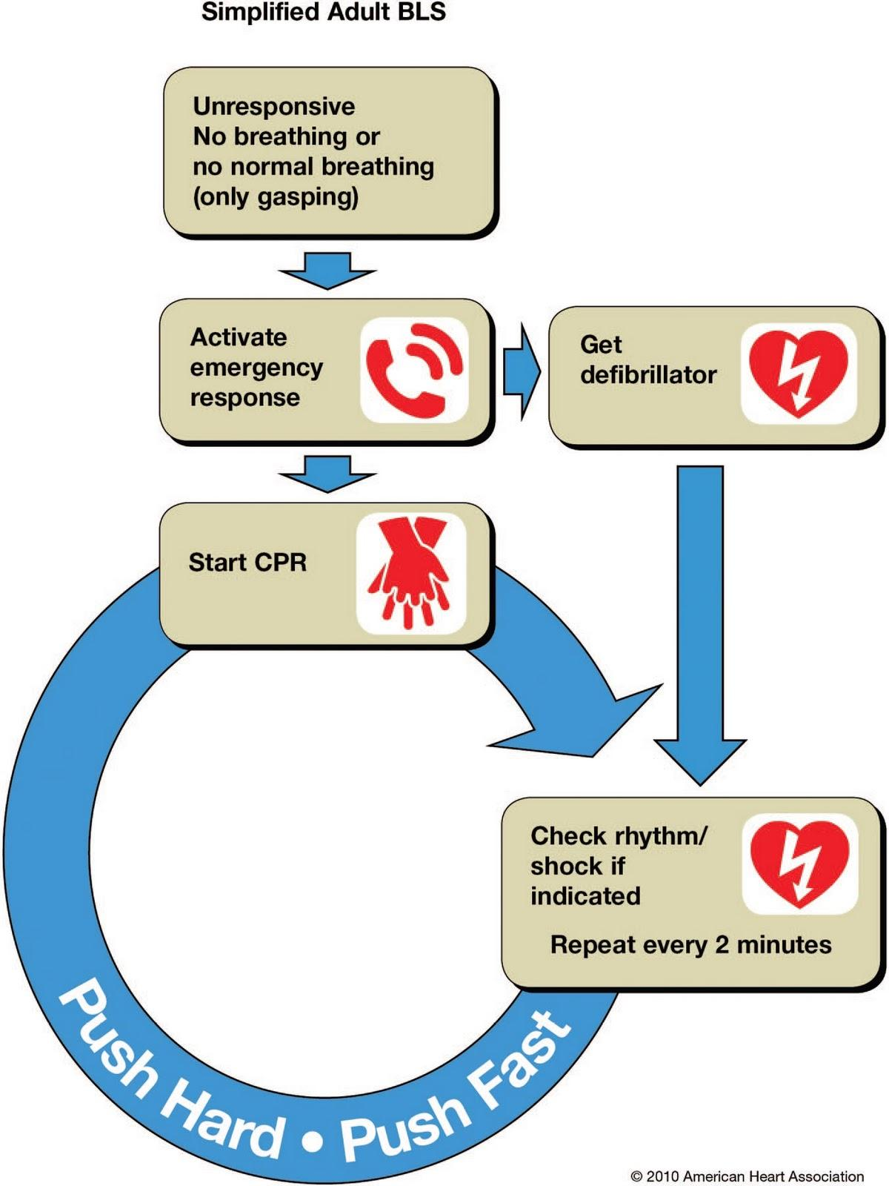

Building Location Information

School Name & Address _______________________________________________________________________

School Phone# __________________________________________________________________

Cross Streets ______________________________________________________________________

AED Location _________________________________________________________

AED Location ___________________________________________________________

AED Location __________________________________________________________

AED Location ___________________________________________________________

AED Location __________________________________________________________

AED Location _____________________________________________________________

School -Based Cardiac Emergency Response Plan

Information for Parents

The safety of your children while they are in our care is extremely important to us. All Wallingford Schools have a Cardiac Emergency Response Team comprised of staffs members certified in CPR-AED who are prepared to respond in the event of a Sudden Cardiac Arrest. We have recently developed a plan to follow which now includes an annual mock drill as part of training and preparation of a real event. We wanted to inform you that your child may come home and mention the drill. The drill will only involve trained adults on the cardiac response team but the drill will take place in the schools one time during the school year.

What is a Cardiac Emergency Response Plan?
A Cardiac Emergency Response Plan is a written document that establishes specific steps to take during a cardiac emergency in a school setting during the school day.

Why is it important?
A planned response to cardiac emergencies will reduce death and disability in school settings like ours and help ensure that chaos does not lead to improper or inadequate response. Preparation is the key to a better response and outcome.

What can parents do?
We encourage all parents to learn CPR through one of these options:

- Take 60 seconds to watch the free Hands-Only CPR video at www.heart.org/handsonlycpr.
- Locate and attend a classroom-based CPR and AED course. Visit www.heart.org/cpr and click the red “Find a Course button.

If you have any further questions please contact your school nurse.

