Events & News:
- PSAT~ October 10th
- Seal of Biliteracy Exam~ Oct 10th
- Conferences~ October 11th
- College & Career Fair~ October 15th
- Capstone Presentations~Oct 16th & 17th
- College Goal Sunday CT~ Oct 21st
- SAT @ Sheehan~ Nov 3rd

PSAT 8/9 & PSAT/NMSQT
Oct. 10th @ 7:30 a.m.
Mark T. Sheehan

Freshmen will be taking the PSAT 8/9 which is intended to be a baseline measure for college readiness. More resources are available here. Each student created a College Board account and linked it to a free academic support resource, Khan Academy.
Students in grades 10 and 11 will be taking the PSAT/ NMSQT.

Students should arrive at the testing rooms with No. 2 pencils and a calculator by 7:30 a.m.

Seal of Biliteracy
October 10th @ Mark T. Sheehan
Seniors are able to earn the Seal of Biliteracy designation on their academic transcript and diploma by reaching proficiency on a world language exam being offered on Oct. 10th. More information about the program can be found here.

Evening Conferences
October 11th @ 6:30 p.m.
Mark T. Sheehan
Sign up to meet with teachers and counselors for a brief discussion of your student. Contact the main office for appointments by Oct 9th.

College & Career Fair
October 15th @ 6:00 - 7:30 p.m.
Oakdale Theater
Over 80 colleges and universities will be in attendance to share information about their programs and opportunities. Sessions for NCAA and Financial Aid will be held.

Capstone Presentations
October 16th @ LymanHall 6:00 p.m
October 17th @ Sheehan 6:00 p.m.
Presentations will highlight the
student's journey through his/her
experience. Students will share their
project along with the skills they
either acquired or refined and
lessons they have learned

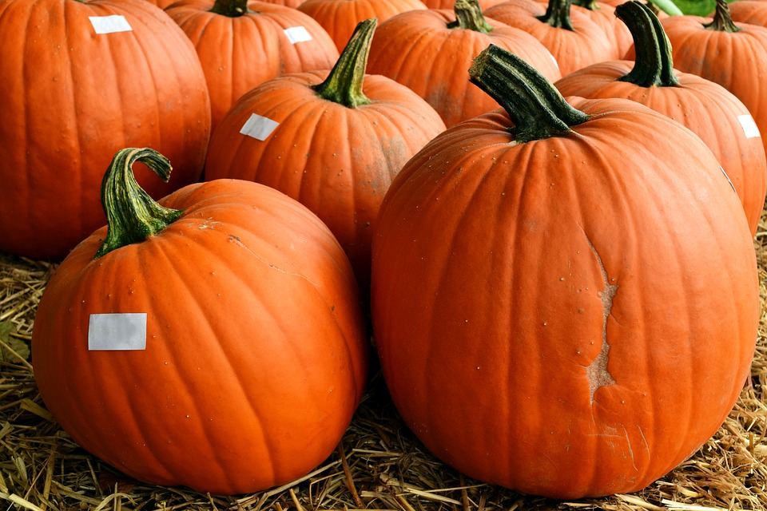

College Goal Sunday CT
October 21st 1:00 p.m. - 4:00 p.m.
Hall High School, West Hartford

A program that aims to support hundreds of students and families with hands-on assistance in completing the FAFSA. For more information and to register, visit this site.

SAT @ Sheehan
Saturday, Nov. 3rd
Register online at collegeboard.org
by Oct. 5th

Students should plan on arriving
by 7:30 a.m. with pencils and a
calculator.

Individual Student Meetings
October/ November
School Counselors will continue meeting with seniors individually to meet deadlines. Students are encouraged to visit their counselors for check-ins and during advertised work sessions to stay in contact with progress.

Freshmen will be meeting with their school counselors this month to review progress in the first quarter, address any concerns, and to get to know their counselor. We look forward to meeting with you!

Coming up...

- Nov. 6th - NO School
- Nov. 18th - Report Cards e-mailed home
- Nov. 12th - NO School
- Nov. 21st - Samaha Bowl
- Nov. 22nd - Carini Bowl

We look forward to seeing you
at our events! If you have
questions, please feel free to
reach out to your counselor!

